Ph.D. Bogdan Kotnik in Aich Dob (Champions league)
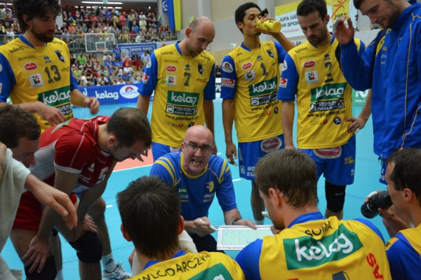

Date of birth | JUNE 1 1976, Slovenj Gradec
Address  Manager: | Permanent (contact address): Hubadova ulica 4, 1000 Ljubljana, SLOVENIA  Tel. no.: 00386 40 635 743  E-mail: bogdankotnik@yahoo.com  Boleslaw Grzyb tel:+48 607 090 961 mail: bolek.grzyb@gmail.com
Education | - Franja Goloba Elementary School, Prevalje.  - Professor of sports education – specializing in tehnique, tactics and physical preparation of volleyball players (Faculty of Sports, Ljubljana).  - Master of Science (Faculty of Sports, Ljubljana).  - Doctor of Science (Ph.D.) – (Faculty of Sports, Ljubljana): “PSYCHOLOGICAL FACTORS OF SUCCESS OF SLOVENE TOP-LEVEL ATHLETES”  - Fivb II COACH.
Player Experiences | - 8 years top-level athlete,  - Seven years of playing volleyball for senior national team of Slovenia.  - 9th place senior European championchip (Ostrava 2001).  - Played for national team of all younger selections of Slovenia.  - State youth champion and state junior champion.  - 2nd place Slovenian CUP 1997/1998 (Olimpija Ljubljana).  - 2nd place Slovenian CUP 1998/1999 (Olimpija Ljubljana).  - 2nd place Slovenian championchip 1999/2000 (Olimpija Ljubljana).  - 1st place Slovenian CUP 2000/2001 (Fužinar Ravne).  - 2nd place Slovenian CUP 2001/2002 (Fužinar Ravne).  - 2nd place Slovenian CUP 2003/2004 (Calcit Kamnik).  - 2nd place Slovenian championchip 2003/2004 (Calcit Volley).
Ph.D. Bogdan Kotnik in ACH Volley Ljubljana (Champions league)

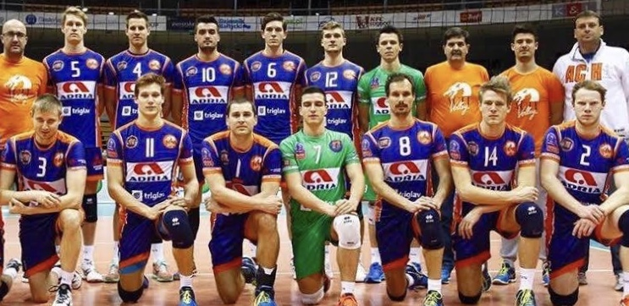

Experiences in profession | 2002 – 2004 Fužinar Ravne  - 1st place youth male championchip of Slovenia  2006-2008 ŽOK TPV Novo mesto  - 2nd place female senior - SLO championship (2007)  - 2nd place female senior - SLO CUP (2007)  2009/2010 and 2010/2011 Calcit Volleyball  - Final four male SLO CUP 2009 (Calcit Volleyball).  2012/2013 Aich Dob:  - ¼ final CEV CUP  - 2nd place Middle Evropean league  - 1st place Austrian league (main phase10/10; ¼ final - 3/3;1/2 final - 3/3  - 1st place Austrian league (final ranking), second place for Hypo Tirol (member of Champions league). Aich Dob → Champions league.  2013/2014 Aich Dob - Champions league  2014/2015 ACH VOLLEY LJUBLJANA  - Champions league  - 3rd place Middle Evropean League  - 1st place Slovenian league  2015/2016 ACH VOLLEY LJUBLJANA  - Champions league  - 1st place Middle Evropean League  2017/2018 Trefl Gdansk (POLAND-PlusLiga) - with Andrea Anastasi  - 1st place – GOLD MEDAL PUCHAR POLSKI  - 3rd place Polish Championship
Ph.D. Bogdan Kotnik in Poland - Trefl Gdansk
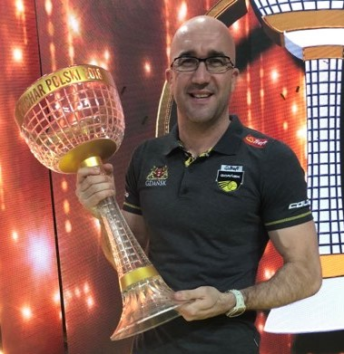

Languages | • Active: Slovenian, English (official certification), German (basic), Italian (basic), Croatian and Serbian (active).
Published articles | - Kotnik, B. (2002). Training Conditions, Education and Social Status of Slovene Volleyball Players. Undergraduate thesis, Ljubljana: Faculty of Sports  - Kotnik, B. (2004). Comparison of Sport Identities of Slovene and Bosnian Volleyball Players. Šport, LII (3), 20-24.  - Kotnik, B. (2008). Sport Identities of Volleyball Players (comparison of cultures). Masters thesis, Ljubljana: Faculty of sport.  - Kotnik, B. (2009). Psychological factors of success of Slovene top-level athletes. Doctor thesis, Ljubljana: Faculty of sport.  - Kotnik, B. (2010). The way of reacting in a stressful situation and factors of success of the Slovene top athletes in the Olympic Games. Sanitas et labor, 8, 91-106.  - Kotnik, B. (2011). Vpliv treninga globinskih skokov na višino skoka ter na jakost plantarnih in dorzalnih fleksorjev stopala. ФИЗИЧECKAЯ KYЛbTYPA И CПOPT B COBPEMEHHbIX YCЛOBИЯX: COCTOЯHИE, ПPOбЛEMbI, HAПPABЛEHИЯ MOДEPHИЗAЦИИ, 38-44.  - Kotnik, B. (2012). Sport identity of volleyball players (an interecultural comparison). Kinesiologia Slovenica, 18, 1, 38-52.  - Kotnik, B. (2012). Some psychological traits of Slovene Olympions (Beijing 2008) – a gender comparison. Kinesiologia Slovenica, 18, 2,5-18.

