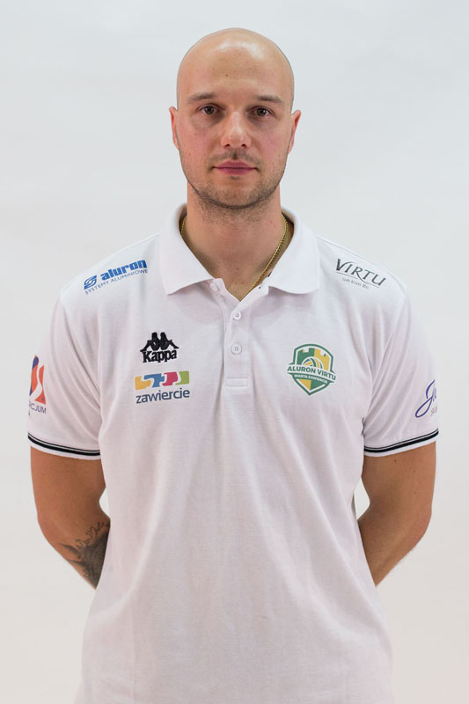
CURRICULUM VITAE

PERSONAL DETAILS :

Name : Jakub Gniado

Adress: 14-400 Pasłęk
Piłsudskiego Street 11b/14

Contact mobile : +48 508099170

E-mail jakubgniado@gmail.com

Date of birth: 08/05/1984
Marital status: single
Nationality: Polish

EDUCATION:

2004 - 2009 Academy of Physical Education and Sport, Gdansk, Poland
Specialization - Tourism and Recreation
Speciality: Fitness Recovery / Physical Recreation
Academic Title: Master Degree

2003 - 2004 State Higher School of Vocational Education, Elbląg, Poland
The Institute of Pedagogy and Languages
Specialization : English Philology

WORK EXPERIENCE:

05.2018 – till now Polish National Volleyball Team
Workstand – Strength & Conditioning Coach
Professional Duties :
- Planning full program for preparation for the season
- preparation of the strength program for volleyball players
- preparation of nutrition & supplementation plan for volleyball players
- planning the fitness recovery
- core stability exercises
- help in teams’ trainings
- 2018 World Championship

07.2017 – 05.2018 Polish National Volleyball Team B
Workstand – Strength & Conditioning Coach
Professional Duties :
- Planning full program for preparation for the season
- preparation of the strength program for volleyball players
- preparation of nutrition & supplementation plan for volleyball players
- planning the fitness recovery
- core stability exercises
- help in teams’ trainings
- 9th place in U23 World Championships

07.2016 – till now KS Aluron Virtu Warta Zawiercie (PlusLiga)
Workstand – Strength & Conditioning Coach
Professional Duties :
- Planning full program for preparation for the season
- preparation of the strength program for volleyball players
- preparation of nutrition & supplementation plan for volleyball players
- planning the fitness recovery
- core stability exercises
- help in teams’ trainings
- 9th place in 2017/2018 season
- 4th place in 2018/2019 season

01.2016 – 06.2016 CSMMA Gym – Pompano Beach, FL, USA (internship)
Workstand – Strength % Conditioning Coach / Masseur
Professional Duties :
- preparing players for fights
- preparing plans for fighters
- conducting massages
- conducting Core Stability lessons
- conducting stretching lessons
- strength training
- training with crossfit elements ( bodyweight + equipment)
- MetCon training ( HIIT, Tabata, EMOM)
- strength and force training

08.2015 - 01.2016 Matrix Fitness Elbląg - Elbląg
Workstand – Personal Trainer / Athlete’s Preparation Trainer / Fitness Instructor
Professional Duties :
- conducting personal trainings
- conducting Core Stability lessons
- conducting stretching lessons
- strength training
- training with crossfit elements ( bodyweight + equipment)
- MetCon training ( HIIT, Tabata, EMOM)
- strength and force training

07.2014 – 06.2015 BKS Aluprof Bielsko – Biała (Orlen Liga Kobiet)
Workstand – Athlete’s Preparation Trainer
Professional Duties :
- Planning full program for preparation for the season
- preparation of the strength program for volleyball players
- preparation of nutrition & supplementation plan for volleyball players
- planning the fitness recovery
- core stability exercises
- help in teams’ trainings

05.2014 – 07.2014 Polish National Volleyball Team B – (Internship)
Workstand – Athlete’s Preparation Trainer
Professional Duties :

- cooperation with one of the best polish volleyball athlete’s preparation trainers – Andrzej Zahorski
- preparation of the strength program for volleyball players
- preparation of nutrition & supplementation plan for volleyball players
- planning the fitness recovery
- core stability exercises
- help in teams’ trainings

03.2014 – 05.2014 Asseco Resovia Rzeszów (7 x Polish Volleyball Champion) – Rzeszów (Internship)
Workstand – Athlete’s Preparation Trainer
Professional Duties :

- cooperation with one of the best polish volleyball athlete’s preparation trainers – Andrzej Zahorski
- preparation of the strength program for volleyball players
- preparation of nutrition & supplementation plan for volleyball players
- planning the fitness recovery
- core stability exercises
- help in teams’ trainings
- additionaly conducting personal exercises with V-ce World Champion in Volleyball – Wilfredo Leon and Yoandry Diaz
- V-ce Championship Of Poland in Volleyball 2013/2014

10.2013 – 03.2014 Shanghai Guohua Life Volleyball Club – Shanghai, China
Workstand – Personal Trainer/Therapist
Professional Duties:

- cooperation withTim Grover – Michael Jordan’s personal trainer (nowadays many NBA Stars eg. Kobe Bryant,Dwyane Wade) and Olympic 110m hurdles champion Liu Xiang

- conducting personal exercises with Kinga Kasprzak (professional volleyball player, National Team Member, Champion of Poland)
- athlete’s preparation
- preparing all season’s physical training plan
- preparing all season’s sports supplementation and nutrition plan
- stretching, core and stability exercises
- special exercises with range of vertebral rehabilitation
- massages and manual therapy

05.2013 – 10.2013 KS Polonia Pasłęk (Athletes Section) – Pasłęk, Kraszewskiego 2 Street
Workstand – Personal Trainer/Therapist
Professional Duties :
- conducting personal exercises with javelin throwers ( Karolina Bołdysz 5th place in Junior
World Championships, Kacper Oleszczuk 4th place in Junior European Championships, National Team Members, World Cup Members)
- athlete’s preparation
- sports supplementation and nutrition
- stretching, core and stability exercises
- special exercises with range of vertebral rehabilitation
- massages and manual therapy

07.2012 – 05.2013 Czarny Potok Resort & SPA – Krynica-Zdrój, Czarny Potok Street 65
Workstand – Fitness Supervisor / Fitness Instructor
Professional Duties :
- supervising the work of people employed in the department
- Team management
- preservation of the qualitative standards of the JW Hotels & Resorts Company
- administrative work
- conducting Nordic Walking, Aqua-Gym and Terrain Activities
- conducting Fitness Training
- conducting Relaxation Training
- conducting Gymnastic with Tai Chi elements and special exercises with range of vertebral
rehabilitation
- hotel massages – helping SPA Department
- giving advices and consultation about training, nutrition and wellness
- creating hotel packets

01.2011 – 06.2012 Indywidualna Praktyka Rekreacyjno Zdrowotna (Own Company) / Krynica Conference
& Spa Hotel - Krynica- Zdroj, Park Sportowy Street
Workstand – Wellness & Fitness Instructor / Masseur
Professional Duties:
- conducting Nordic Walking, Aqua-Gym and Terrain Activities
- conducting Fitness Training
- conducting Relaxation Training
- conducting Gymnastic with Tai Chi elements and special exercises with range of vertebral
rehabilitation
- hotel massages
- massages with customer acces (range of classical, sports, relxed, aromatherapy)
- giving advices and consultation about training, nutrition and wellness
- creating hotel packets (slim, active and relaxation)
- preservation of the qualitative standards of the company
- building relationship and contact with customers

07.2010 – 12.2010 Krynica Conference & Spa Hotel – Krynica- Zdroj, Park Sportowy Street
Workstand – Wellness & Fitness Instructor / Masseur
Professional Duties:
- conducting Nordic Walking, Aqua-Gym and Terrain Activities
- conducting Fitness Training
- massaging the customers
- giving advices and consultation about training, nutrition and wellness
- creating hotel packets (slim, active and relaxation)
- preservation of the qualitative standards of the company
- building relationship and contact with customers

LANGUAGES:

English - fluent
Russian - basic
Polish - native

PERSONAL QUALITIES:

Communicative, sociable, high level of personal culture, self - discipline, cooperative.

ADDITIONAL SKILLS :

- Professional Course of massage treatment in the range of classical, relaxed and sports massage (educational and skill abilities examination grade – excellent)
- Lifeguard Course
- Computer literate ( Windows XP Operating System, MS Office, Internet )
- Driving licence B (since 2001)
- Functional Training Course
- Training Methodology Course IFAA
- PFS Stretching Instructor Reps
- Massage course

INTERESTS:

Sport, dietetics,medicine, travelling, tourism and recreation,fitness, forcible sports, computers, music, motorization, cinema

